**Problem Statement**

A lot has been found out about gun violence still a strong step is not being taken, neither by government nor by public. Why?

* What does the literature tell you about the topic?

The article tells us that among developed nations, the US is the most homicidal country due to the easy access of many Americans have to firearms. The maps, plots and charts show the rate and nature of that violence, why it happens, and why it is such a tough problem to fix.

### Supporting arguments in the article:

### The United States has 90 guns per 100 people, the [highest ownership rate in the world](http://papers.ssrn.com/sol3/papers.cfm?abstract_id=1090441), while countries like Mexico has just 15, among the 59 countries for which the graph is made using a dataset.

### The federal government, with the support of the National Rifle Association, has no answer to the question: Does gun control work? The First graph studies the issue related to it. America has six times as many firearm homicides as Canada, and nearly 16 times as many as Germany. Reasons could be more permissive gun policies lead to more gun deaths, while more restrictive policies lead to fewer gun deaths (as explained in further graphs). Other evidences from graphs 1-17 in this area, supports the idea that more guns lead to more gun deaths. This problem could be solved with better, more rigorous research. But because the studies were often dealing with limited data and methodologies, many of them couldn’t work through these problems.

### Referring to one of the pdf sources which studied other nation’s theory, if we drop the U.S. from the dataset results in the guns-deaths and countries (59) relationship no longer being statistically significant. There is no good reason to discard the U.S. from the data simply because it has notably more guns per capita than the next-closest nations of Yemen and Finland. To the contrary, if guns have any freedom-related effect, it might be expected that the effect would be most noticeable in the nation with the most per-capita guns, so that nation should be included in the data analysis. So, this argument still doesn’t solve the problem whether a country should give the public, rights to possess a gun or restrict them. So, we see a trend in the graphs showing shootings and homicides have increased, then what could be a possible reason, maybe possession of guns and what if the right to possess a gun is restricted which could decrease homicides. And towards the end, what factors hinders the process on a whole.

* Where and why is the data product (in) effective?

The above problem statement is being expressed through 17 different plots. I would try to focus on the plots to outline the major issue of the data product as a whole.

### Plot 1 shows that America has a very high rate of firearm homicides as Canada, and to be precise around 16 times as of Germany. But there is a lack of basic clarity of the graph. I think if it was a bar graph so content could show the comparison more elaborately, it would have been better. I would want to comment on the dataset as well.

### Plot 2 shows that America has 4.4 percent of the world’s population, but almost half of the civilian-owned guns around the world. I like the idea of the graph. But, we could have merged the plots to make the article concise.

### Plot 3 shows that there have been more than 1,600 mass shootings since Sandy Hook incident saying that there has been an increase in mass shooting cases because people in USA are allowed to carry guns and they misuse it. I think the heatmap could have a legend.

### Based on the information, I managed to obtain dataset showing 185 rows (cases) out of which some has missing values. When removing them, the dataset that we are left with is with 107 rows. So, I assume the numbers in the graph are not exact but maybe the result is still true.

### 

### I also notice that data is varied and for varied years. Maybe we need a base year and then comparison could be most accurate on that.

### Plot 4 tells us about on average, there is around one mass shooting for each day in America.

### Plot 5 says that states with more guns have more gun deaths. I like the idea of this graph.

### Plot 6 backs up the idea of plot 5 with plot 6 saying that it is not just the US; Developed countries with more guns also have more gun deaths. Dataset could even tell more insights about this.

### Plot 7 says America is an outlier when it comes to gun deaths, but not overall crime; as I mentioned the idea is expressed from a data obtained in the year 2000. So, people give reasons such as mental sickness in this country when out of rage they pull out gun and shoot someone. So the idea that mental illness is more prevalent in the US than in other countries is not true and it’s hard to see why it would lead to more homicide, but not more of any other violent crime, in the US. This is still not that clear to me.

### Plot 8 In this it is shown using a 2007 survey that States with tighter gun control laws have fewer gun-related deaths. Guns and drug abuse are presumed to go together. But, again, that was not the case in the state-level analysis. No association was found between illegal drug use and death from gun violence at the state level or for that matter, mental illness and homicides.

### Plot 9 says that Still, gun homicides (like all homicides) have declined over the past couple decades.

### Plot 10 tells us that most gun deaths are suicides in the USA. Did not find data to back this up.

### Plot 11 says more guns more suicides. The box plot shows the information about states in the USA. The article I found at the source tells a whole different story and how insights and conclusion can change based on a dataset for suicides committed in USA. The structure, pattern and time took for the act is a very important and determining factor about the reason or motive of deaths.

### Plot 12 says guns allow people to kill themselves much more easily. This graph makes sense to me and I agree with this conclusion.

### Plot 13 tells us about policies that limit access to guns have decreased suicides. They back this conclusion saying the reduced deaths with strict law. Information is similar to graph but expressed with considering the case with some other country. It is generalizing conclusion. It expresses something similar to Plot 8 so combining the idea into 1 plot could be an approach.

### Plot 14 states that in states with more guns, more police officers are also killed on duty. Kind of repetitive data and information as previous plots.

### Plot 15 shows that support for gun ownership has sharply increased since the early 2000s. People are scared to give away their rights on guns as they are instigated by politicians and other sources. Which in my view can be a valid reason.

### Plot 16 says high-profile shootings don’t appear to lead to more support for gun control in the long term. People have to identify a real issue and support it for long term benefit.

### Plot 17 tells us that specific gun control policies are fairly popular. Some policies are supported by USA people but some of them which says taking away their control over their possession of guns is not acceptable to them which leads to a no solution situation.

### Some graphs are deceptive (details below) and also a conclusion could not be reached because of an unclear roadmap. So, some graphs are ineffective.

* What is your proposal to redesign the data product?

I think according to me there are various points where we can work on the data collection process better and perform data wrangling in a much wider and different way to reach to a whole new conclusion.

Proposal:

1. Collect data for a year which has experienced a very less amount of suicide/homicide cases. Make it a base year and then we should have yearly data with not just the variables which show percentage of firearms, number of firearms possessed, firearms per capita, but other variables like suicide cases, suicide reason, homicide reason, region of maximum homicide, suicidal activity prone region or not (0/1 dummy variable) and many more and regress them to see the correlation and then decide.
2. The current gun violence data product has many challenges. The first one is dataset and second issue it has is consistency. It should focus on all the aspects as mentioned in plot 8 about mental illness so it could happen that such data would change the conclusion or insight a little or maybe largely. So, a data product should handle the challenges it encounters and present the data in a wider prospective.
3. The clear idea of plot 1 is not there so I would also change its design and use a better methodology to express that information.
4. Plot 5 and Plot 6 should give more elaborative description based on more convincing evidences.
5. I would consider multiple rounds of redesign work mainly with the graphs to come to a firm conclusion on the statement that more states with gun possessions more deaths. The reason could be a totally new factor if wrangled more.
6. There should be a clarity of end result to reach to a concrete solution. That could also help us define problem in a better way and in turn, the solution.

* What are potential starting points for a deceptive version and why are they deceptive?

Data visualizations do a fantastic job of showing data in a clear and engaging way but there are many times charts and graphs are poorly crafted, leading to data visualizations that are deceptive. Generally speaking a broken scale can lead to a deception, if dataset is not taken properly, total count is missed there can be chances of deception.

Potential starting point for a deceptive version in the data product:

1. I think the graph showing the R-D change in Plot 17 it has shown some wrong calculations which makes the outcome a little biased.
2. Missing % data in Plot 16 is not shown in the plot mentioned in the article. It is present in the survey link.

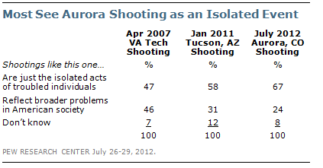

1. Plot 1 and 2: There are some issue with the dataset as we can see a high correlation among variables which is not expressed and considered for the plot. Also, negative correlations are present which tell a different story when explored. The data set should remove any correlated variables and move ahead with the remaining variables or should see the negative relation between variables. This could lead to a deceptive information.

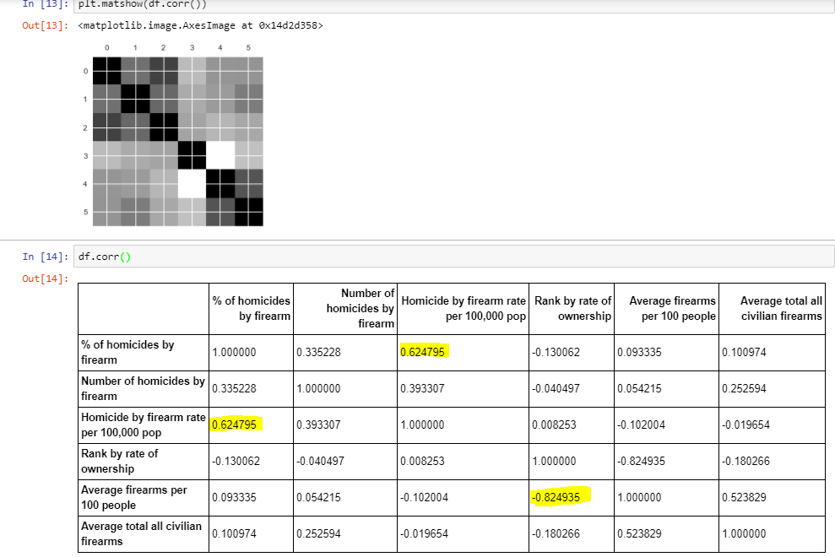

1. The x-axis is not clear what it really is showing by 00-17. Plot 15.
2. Plot 11 shows higher rate and lower rate but a value is missing. The graph makes sense but as we see the trend and for example 1600 deaths is actually a less amount than 39000 in the USA. But, it may be different in a different year or a different year. This information is misleading and not valuable to support the argument.
3. The people graph is not a standard way to represent the percentage change. If someone who doesn’t see the numbers but starts to count the people there he/she may get to some random percentage values.

* Have you obtained access to the mentioned data sources or identified replacements/potentially important additions?

I tried to access the source data files and obtain dataset from it. I found that the sources mentioned an elaborative description of the case and also in some cases contradicted the finding in the graph. Also, the points which could be considered or added in the dataset are also mentioned in the description text of the sources. I still think that obtaining and merging dataset from each individual source file will be the best approach because here the article covers a very wide range of facts and figures for expressing his idea about gun violence in the USA.

Some missing content could be added to the dataset. Year variable could be an important variable. More research on dataset is needed for building a trust on the survey result mentioned in the source files. Backing up the argument in Plot 8, source dataset from plot 13, <https://amaral.northwestern.edu/resources/data-sets/gun-violence-us-schools> shows how different reasons could be the actual cause of suicide or homicide.

